Lab 3 [20% Submission”] Thor Kopenkoskey
Task 1: Screenshot of me going through of a task 1 commands and procedures

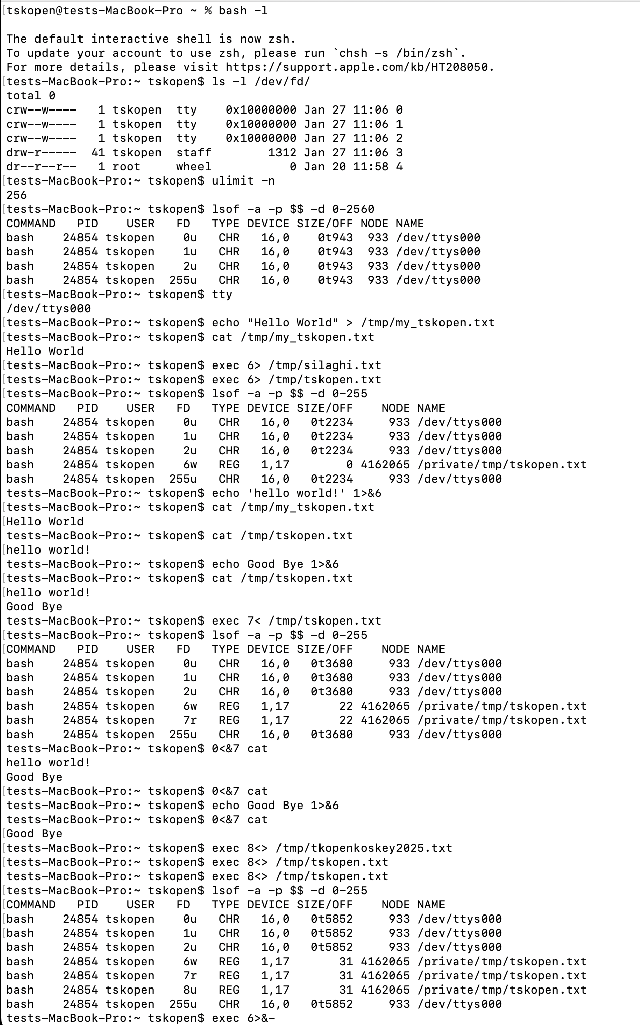
  - WHAT I LEARNED: (1 point) ...
How to read and write to files at various positions
  - WHAT I DID: (1 point) what you did as actions: code/study/read/run code
I studied the various commands and then executed them in my terminal
  - TASK INTENDED PURPOSE: (1 point) what you understand (read/guess) was the intended educational purpose of the task
learn how to open, read, and write files and other programs in bash is very important to understanding program mechanisms
  - WHY IS THIS IMPORTANT: (1 point) what did the task description say about the significance of the information
This is common to all programming languages and operating systems in use, making it an important part of understanding current technology and programs cooperating with each other
  - OPTIONAL SUGGESTIONS: what can be improved in the task to better achieve the declared purpose, or to refine the purpose

Task 2
Here is a screenshot of me running the Task 2 commands, however due to a typo I just kicked out of the bash terminal… I later resolved this bug in the following screenshot
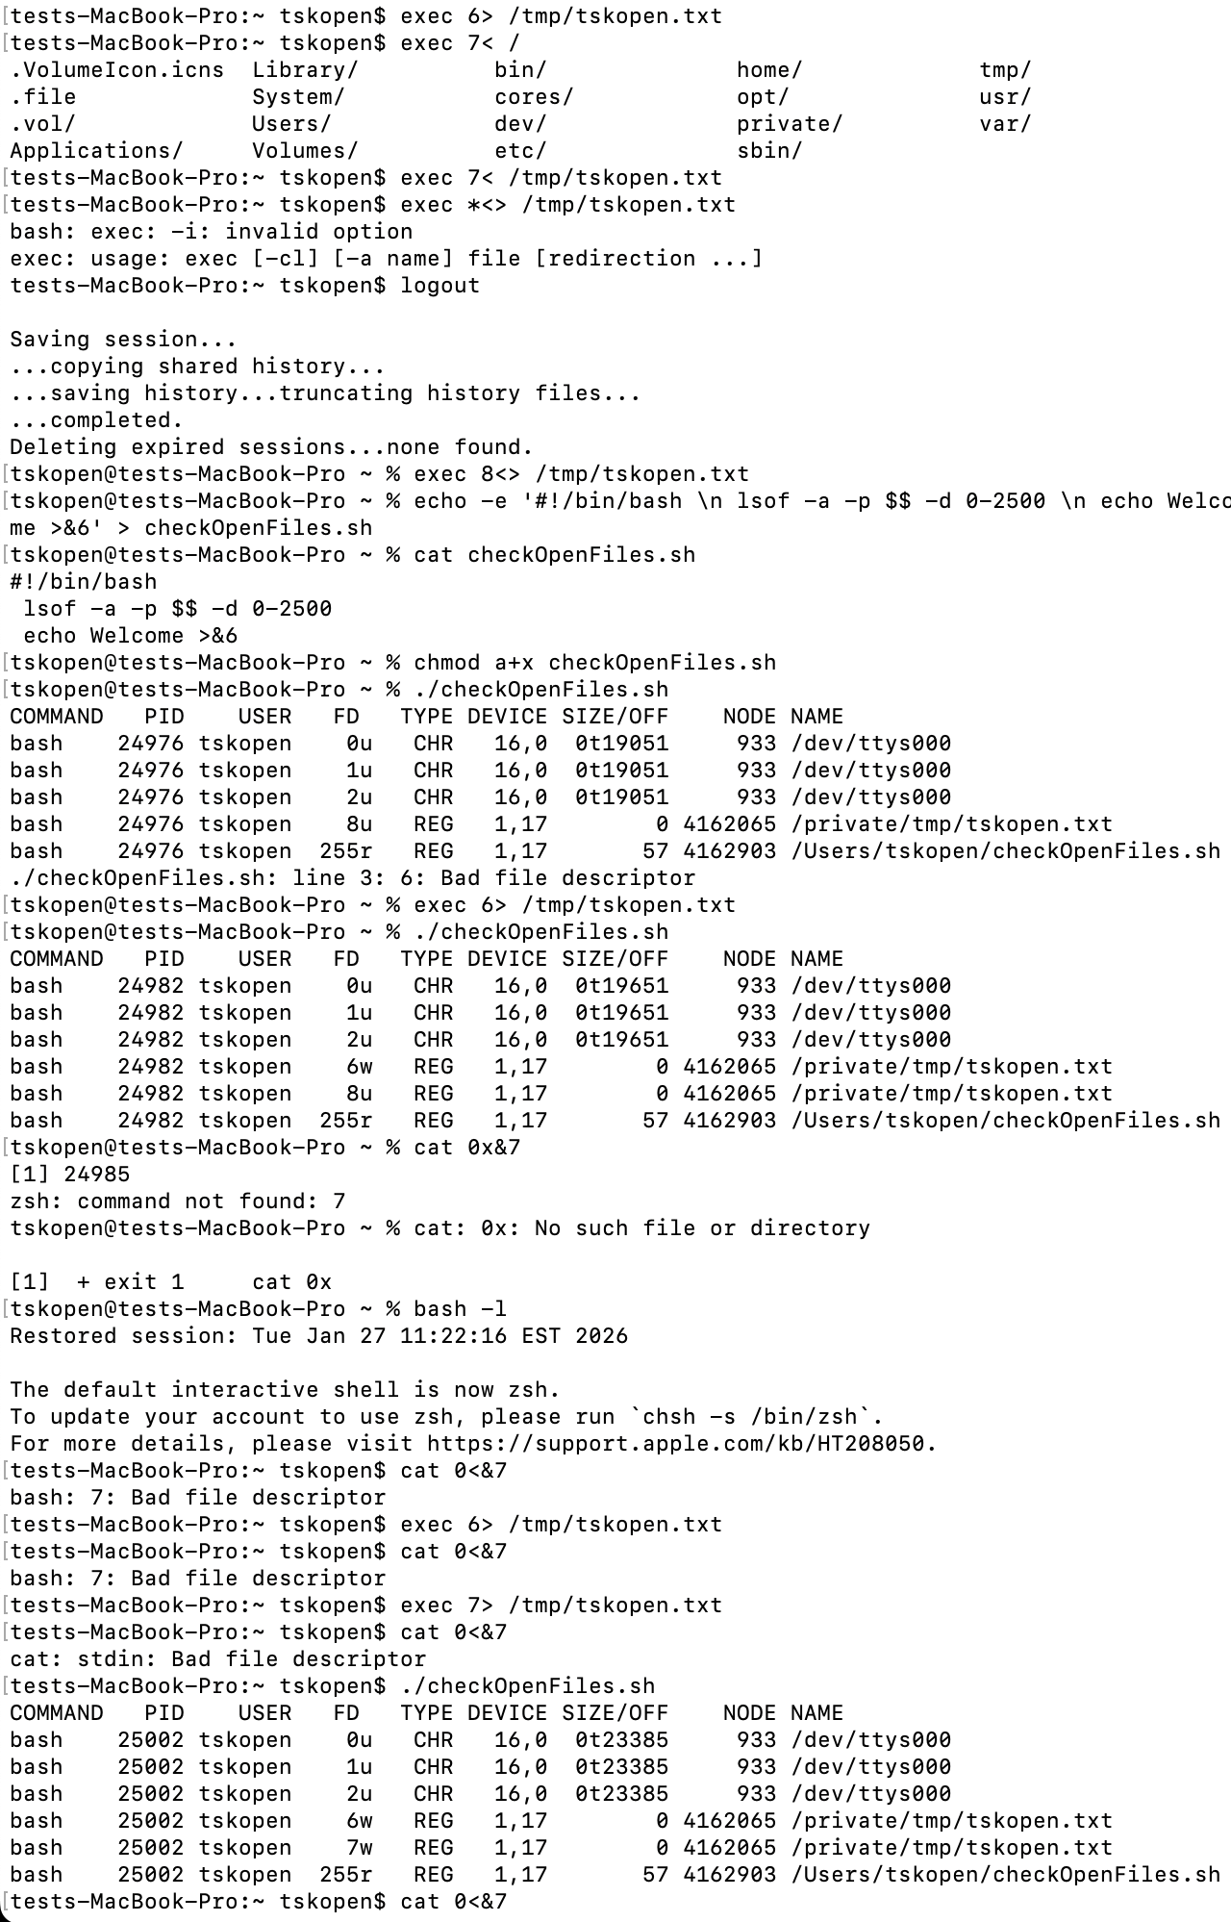
Here is a screenshot of me finding the error in my steps and correcting it by rerunning exex commands while in the bash terminal
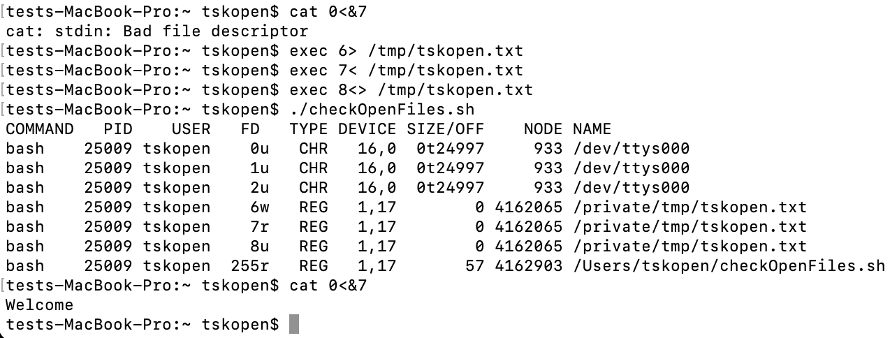
  - WHAT I LEARNED: (1 point) ...
How to read and write to files through bash operators
  - WHAT I DID: (1 point) what you did as actions: code/study/read/run code
I initalised the bash input read/write files and then read file 6 through file 7.
  - TASK INTENDED PURPOSE: (1 point) what you understand (read/guess) was the intended educational purpose of the task
Learn how to use bash to communicate to other files
  - WHY IS THIS IMPORTANT: (1 point) what did the task description say about the significance of the information
File communication is the basis for many projects and I will use it throughout my career in development.
  - OPTIONAL SUGGESTIONS: what can be improved in the task to better achieve the declared purpose, or to refine the purpose
Task 3
Here is a screenshot with all task 3 commands and operations
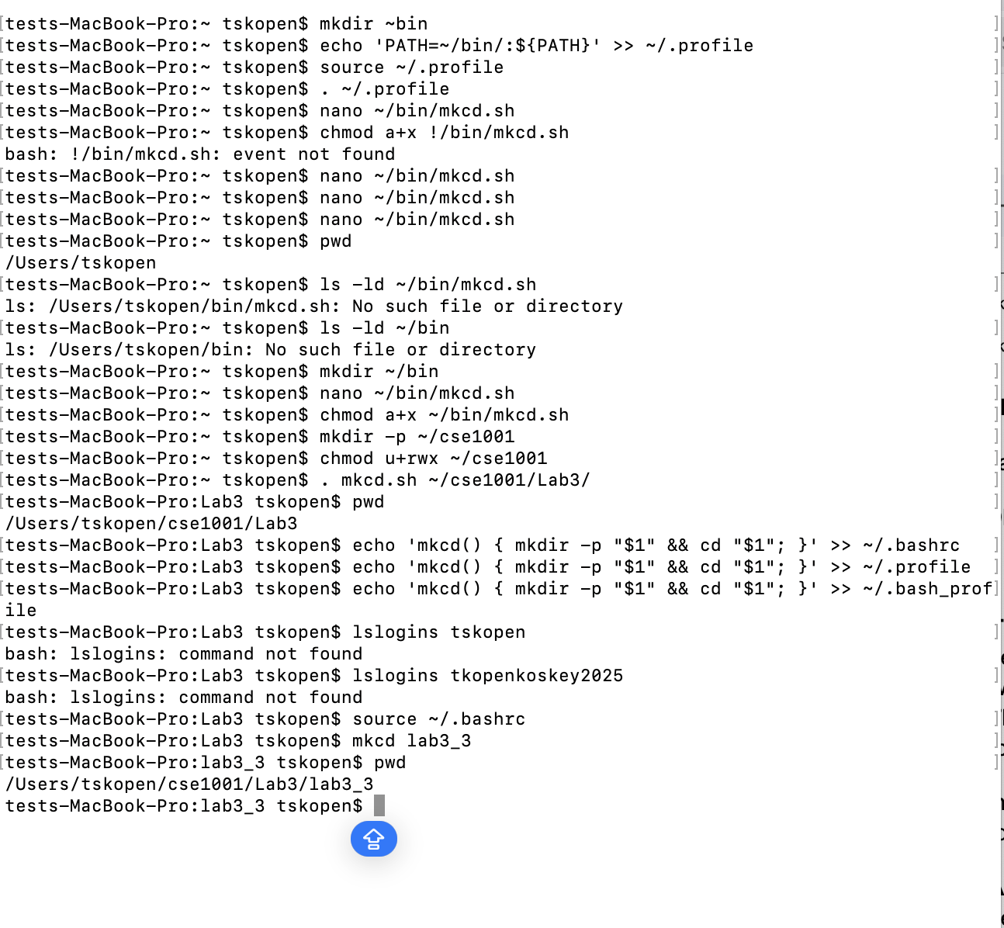
  - WHAT I LEARNED: (1 point) ...
How to make scripts to create commands that act as tools in development
  - WHAT I DID: (1 point) what you did as actions: code/study/read/run code
I created a shell program to run when I want to make a directory and move into it
  - TASK INTENDED PURPOSE: (1 point) what you understand (read/guess) was the intended educational purpose of the task
Learn how to use bash to create developer tools
  - WHY IS THIS IMPORTANT: (1 point) what did the task description say about the significance of the information
This will allow me to create tools to make development faster in my future projects
  - OPTIONAL SUGGESTIONS: what can be improved in the task to better achieve the declared purpose, or to refine the purpose

